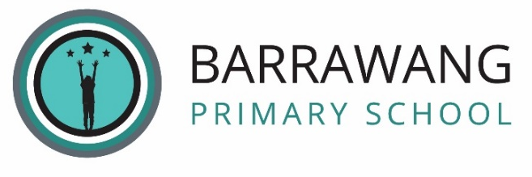
HIRE AND LICENCE OF SCHOOL FACILITIES – COMMUNITY INFORMATION

Barrawang Primary School has the following facilities available for hire (for one-off or very short-term use) or licence (for regular, on-going use) to the community:

- Indoor gymnasium
- Outdoor basketball and netball courts
- Music room space
- Classroom space

Barrawang Primary School Council will only consider applications for the hire or licence of the above facilities if the purpose is for educational, recreational, sporting or cultural activities for:
- Students at Barrawang Primary School;
- the local community and government organisations; or
- young persons and not for profit organisations
and in circumstances where the facilities are not required for ordinary school purposes.

Barrawang Primary School Council will not consider applications for the hire or licence of the above facilities for private and personal use which are contrary to the school’s values. This includes activities that
- infringe on the delivery of school programs
- may bring the school into disrepute
- are likely to cause damage or risk to school students, school buildings or property
- create excessive noise or pose nuisance to nearby residents
- are illegal

The process at Barrawang Primary School for applying to hire or licence school facilities is to contact the school to discuss your interest in hiring our school facilities and you will need to enter into a written agreement with the school council in which fees may be payable.

The agreement between you and the school council will require you:
- to have adequate public liability insurance (other insurance might be requested, depending on the use of the facilities);
- in most instances, to pay a hire or licence fee (amount set by council) for the use of the facilities;
- in most instances, evidence of a Working with Children’s Check Card (WWCC) may be applicable depending on the hire nature for the use of the facilities and adhere to Child Safe Standards when onsite;
- disclose if the consumption of alcohol will take place and to pay for appropriate liquor licensing (if approved);
- in most instances, to pay a security deposit (amount set by council); and
- to be bound by the terms and conditions contained in the agreement.

School Council retains the right to exclude any external parties who wish to use the school facilities if they deem the proposed use to be inappropriate.

Please contact the school’s office on 8652 8590 or email at barrawang.ps@education.vic.gov.au to discuss your hire requirements or to obtain further information.

